Snowmobile Safety Course

Sponsored by the Ohio Ridge Riders Club.
Held at the Town of Ohio Recreation Hall, 140 Nellis Road, on Saturday November 7, 2026 from 9 AM to 5 PM.

Pre-registration is required at: Event - New York Snowmobile Safety Course - November 7, 2026 in Cold Brook, NY
Lunch will be provided by the Ohio Ridge Riders Club.
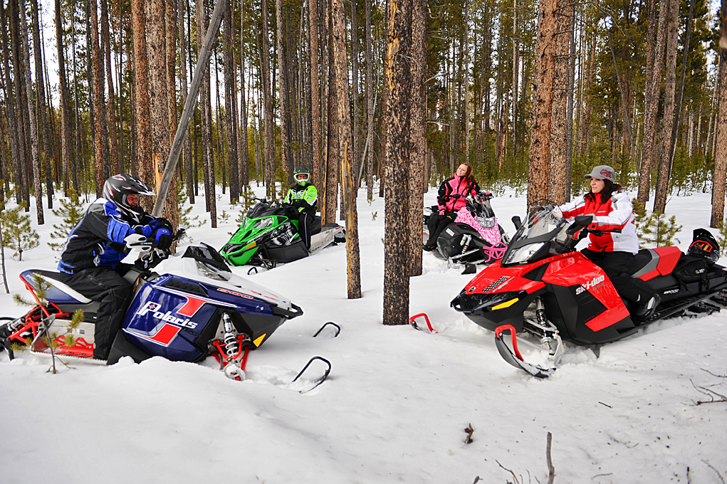

Class is required for youths between the ages of 10 and 17 to operate a snowmobile in New York State.

